Walk 15 The Marcle Ridge
Last walked in July 2019

Description. A 7 km (4.3 mile) walk over farm and woodland paths and tracks, of which 1½ miles is along the Marcle Ridge with its spectacular panoramas.
Start. The Marcle Ridge car park and picnic site, 8½ miles south east of Hereford. Explorer Map 189 Grid 630346
Directions from the Fire Station. (Turn milometer to zero). 200 yards passed the Fire Station TR signed 'Fownhope B4224'. After 3.9 miles, (in Mordiford) TL signed Woolhope 3. After 6.8 miles, (in Woolhope) TL at a T junction and continue on main road signed for Ledbury 8. Keep R thru the next village and at a road junction, after 7.7 miles, TR signed Much Marcle 4. Go up the hill and along the ridge and at 8.8 miles TR at the next junction on the R and park in the layby on the L. (2 blue sign posts at this site: Unsuitable for HGV’s and Unsuitable for LGV’s).

The route along Marcle Ridge has been an important line of communication for many millennia. The long, gentle slope of its eastern side offers well drained, easily worked agricultural land and this is reflected in the huge number of prehistoric, Roman and medieval sites recorded. During the Bronze Age and Iron Age farmsteads would have been scattered over this slope with the ridge itself used as a vantage point

1. Lay By. From the lay by you go back up to the Much Marcle road and go up the public footpath steps on your R, over a stile and into F1, (you will now be following the R hand edge of the fields with woods on your R for the whole length of the ridge, heading towards the TV and Radio Mast). Continue along the ridge and thru a number of fields(7), passing the radio mast(L) that’s in field 6. Continue along the R hand edge of F7, and at the end you go down some wooden steps and thru a kissing gate onto an enclosed track.

2. Enclosed Track. TR and continue down hill along the enclosed track. Ignore all paths off this track until you reach the bottom. Before you get to the old farm house (Grey Hill Barn) that’s on the R hand side, and by a public footpath sign, you TR and go thru the metal gate into a field. Walk straight ahead (going north), under the double power lines and along the R side of a line of trees to reach a farm track where you TL and follow the track around the R hand edge of large fields. The stony track crosses a very small stream and goes uphill, bends to the R, and then joins a narrow road. TL and walk uphill along the narrow road that soon goes downhill to join a main road at a T-junction. TR a few metres before the T-junction to go over a cattle grid, thru double wooden gates onto a tree lined grassy track. With a fence on your L, follow this level track thru a metal gate and on towards farm buildings. As you approach the farmyard, keeping to the field edge, you pass a pond on your R and then go thru a metal gate into a farmyard.
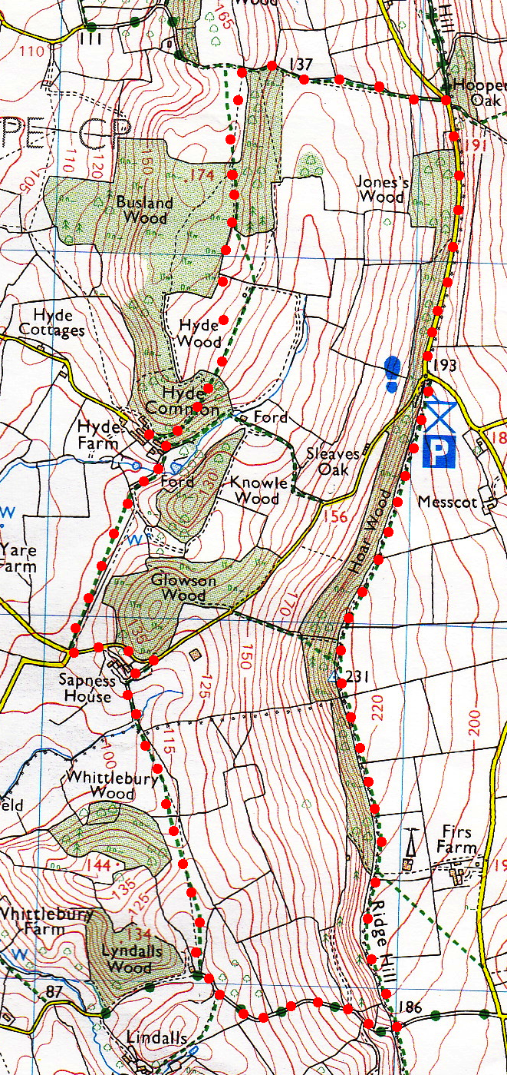
3. Duck Pond. Follow the farm track uphill and to the L, after about 50 metres, (at the end of an open barn), turn sharp R and continue up a track into the woods. Follow the track along the edge of the wood, (ignore a track going off to the L) and when the track you are on turns L, you carry straight on and cross a stile into an arable field. There is no clearly defined path but you go straight across the large arable field, to reach the corner of the woods. Continue in the same direction along the top edge of the field, (the wood is on your L), until you reach a metal gate/stile in the far top L hand corner of the field. Cross over the stile to go into the wood, (if in any doubt look at your map). Walk along the track thru the wood and when the track turns L you carry straight on to cross a metal gate/stile into a meadow. Cross the meadow keeping parallel to the wood on your R to reach a mound ahead that used to be a lime kilns. Pause to take in the panorama to your L of the Black Mountains with Hay Bluff on the northern end. The village of Woolhope is below you. The foreground is part of the Woolhope Dome – an area of limestone surrounded by the more typical red soil of Herefordshire and its underlying Old Red Sandstone. It explains the mound which turns out to be lime kilns. At the lime kilns you TR and make for a metal gate/stile at the end of the wood.
1
3
4

4. Lime Kilns. Cross the metal gate/stile and go downhill along the L edge of the wood. Leave the wood thru a metal gate and continue on in the same direction, keep to the L field edge as you go up a large field. When you reach the top L hand corner of the field you go thru a metal gate into a short length of enclosed track to join a minor road. You are now at Hooper’s Oak. In 1575, about half a mile from here, a landslip buried buildings. A house near the sight is called The Wonder, In memory of this catastrophic event. TR here and follow the road for half-a-mile back to the picnic area.
2

